1. **Agenda**:
   1. Send ProducerRecord to KafkaTemplate instead of topic, key, value.
2. 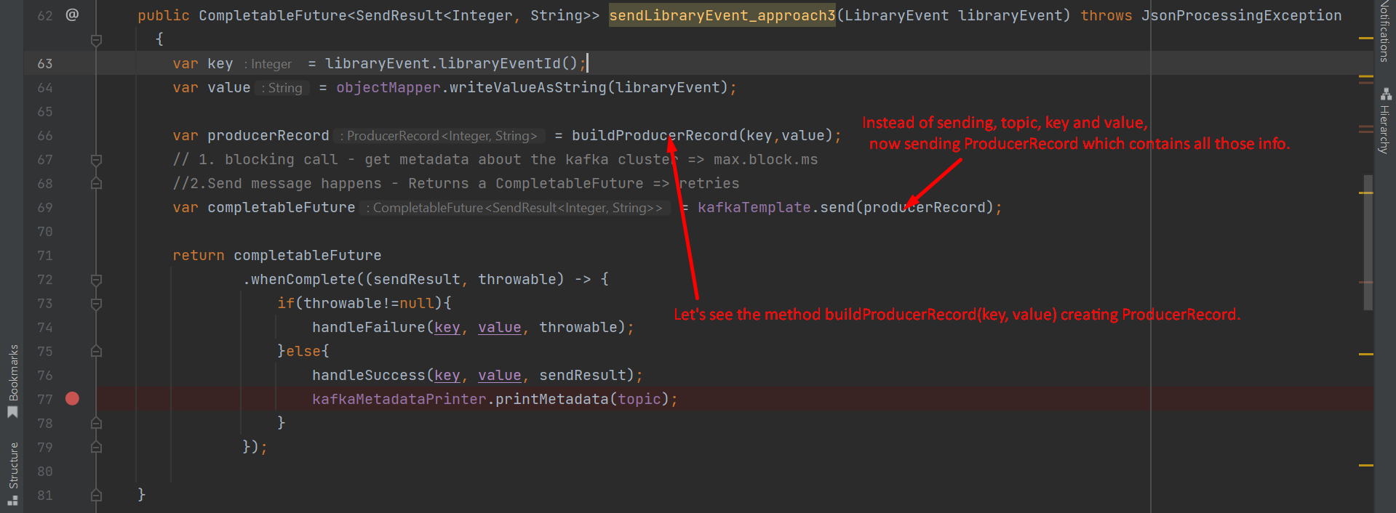
3. 